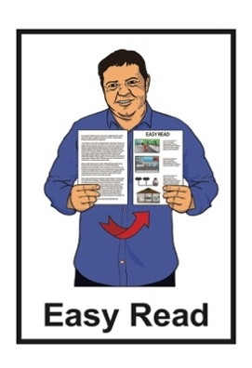Te Kāwanatanga o Aotearoa – New Zealand Government logo. 


New Zealand

Traveller Declaration –   
for air and sea travellers

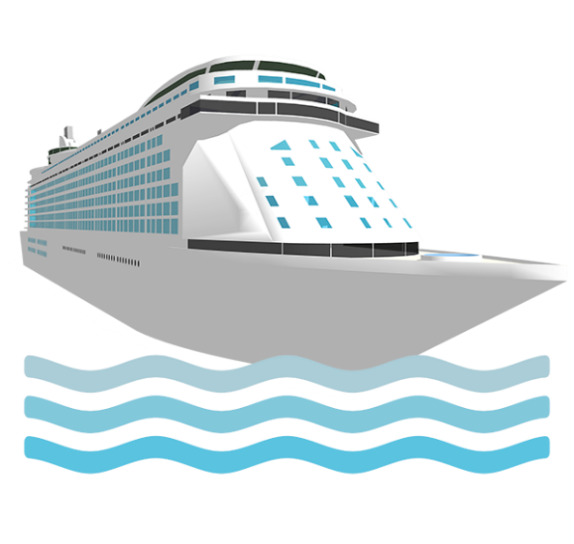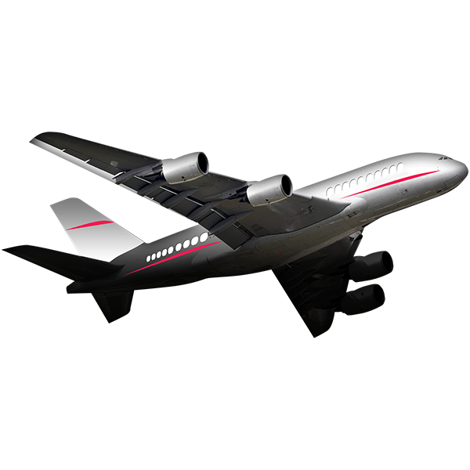

Updated: July 2024

# Before you start

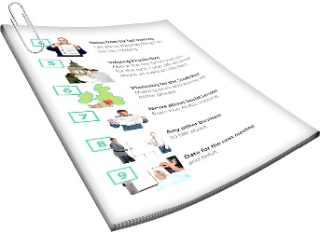

This is a long document.

It can be hard for some people to read a document this long.

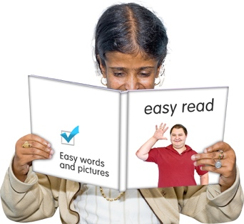Some things you can do to make it easier are:

read it a few pages at a time

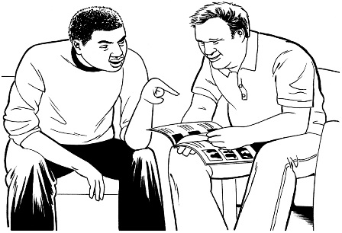set aside some quiet time to look at it

have someone read it with you to support you to understand it.

# What you will find in this document

**Page number**:

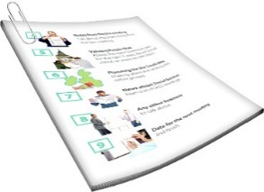

What is this document about? 4

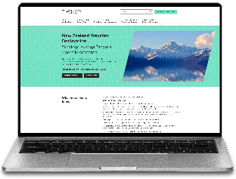

How to fill in a declaration 7

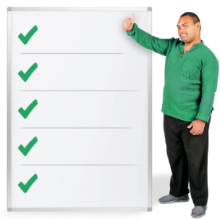What you need to fill in

your declaration 11

Information about visas 16

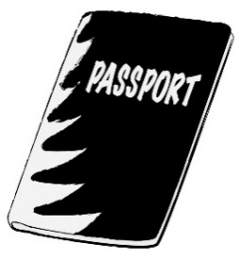

A New Zealand Electronic Travel Authority 17

**Page number:**

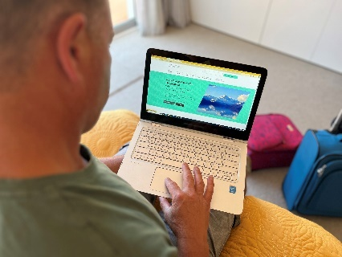When you can submit your

declaration 20

Making changes to your  
declaration 23

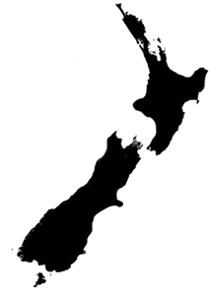

When you arrive in

New Zealand. ..25



Checklist for travelling to   
New Zealand 27

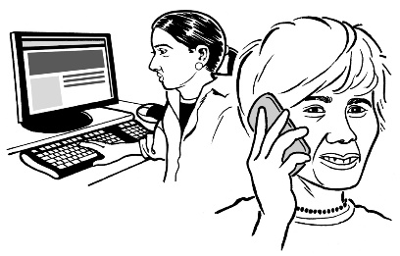

How to contact us 28

# What is this document about?

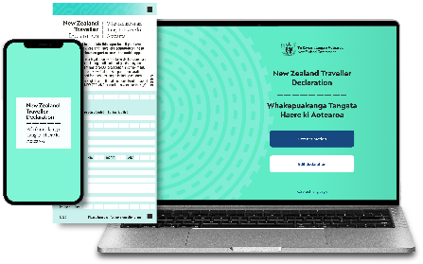

This Easy Read document is from Customs New Zealand about the **New Zealand Traveller Declaration.**

  
  
The **New Zealand Traveller Declaration** is also called:

the NZTD

the declaration.

A declaration needs to be completed by everyone who travels to New Zealand.

  
In this document the words **us / we** mean Customs New Zealand.

The **New Zealand Traveller Declaration** is a system that collects information about:

your travels

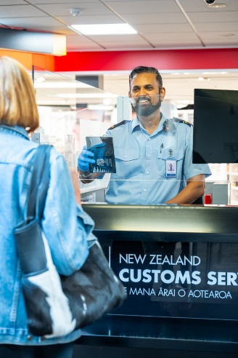what you tell **customs** – they stop dangerous items from coming into New Zealand

what you tell **immigration** – they make sure people come into New Zealand legally

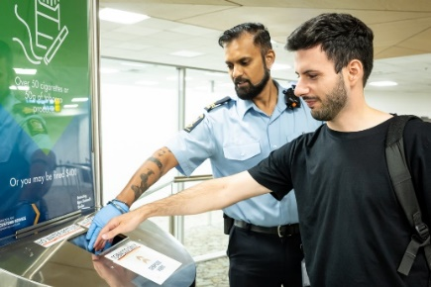what you tell **biosecurity** – they stop dangerous diseases from getting into New Zealand.

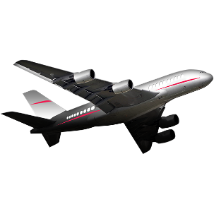People need to fill in a declaration if they are arriving in New Zealand:

by plane

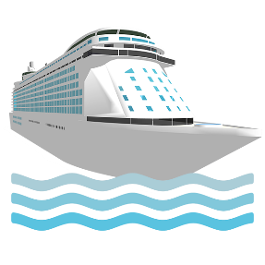on a ship.

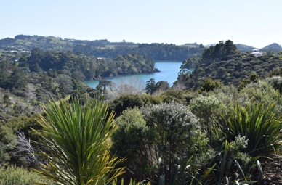The declaration helps to keep our:

tangata / people safe

whenua / land safe.

# How to fill in a

# New Zealand Traveller Declaration

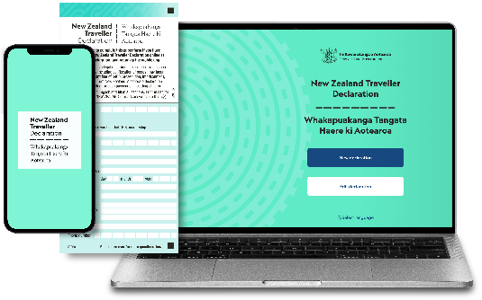There are 3 ways to fill in a declaration:

on our website

on our NZTD **app**

on our paper form.



An **app** is a program you can

download on your:

phone

tablet.



Pages **9** to **10** of this document will go through these 3 ways.

It is okay to get someone to support you to fill out your declaration.

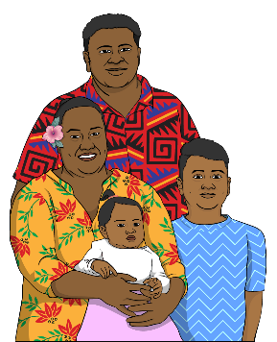

Every person travelling to

New Zealand needs to have their own declaration filled out.

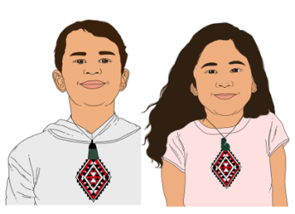

A declaration must also be filled out for:

children

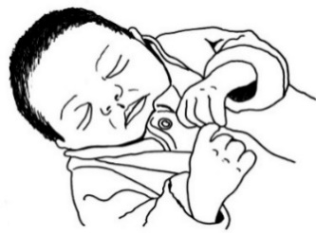infants / babies.

The New Zealand Traveller Declaration is free.

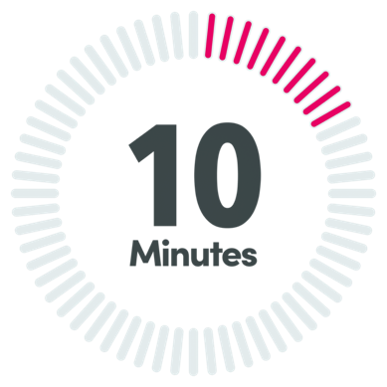

It will take about 10 minutes to complete.

## Our website:

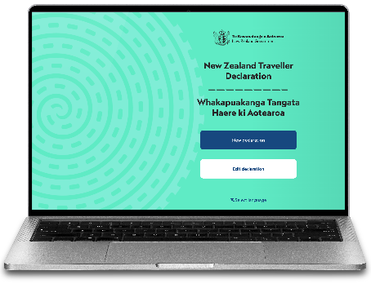You can fill in the form on the New Zealand Traveller Declaration website here:

**shorturl.at/rxDJZ**

## Our app:

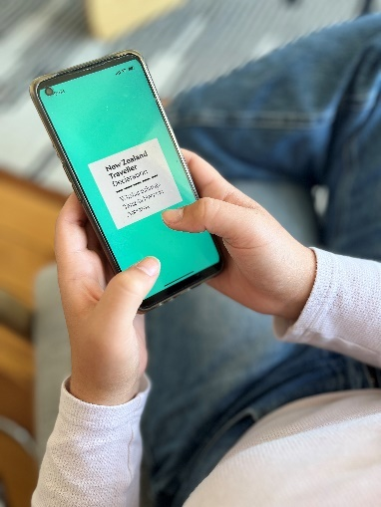You can download the NZTD app on your:

phone

tablet.



You can find more information about how to download the app on our website here:

[**shorturl.at/lzEPU**](https://shorturl.at/lzEPU)

## On paper:

Some people find it hard to fill out their declaration online.

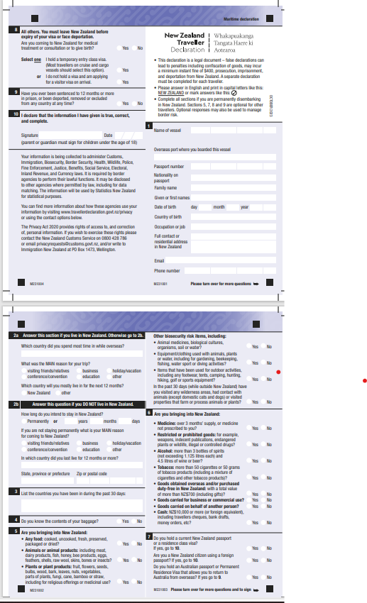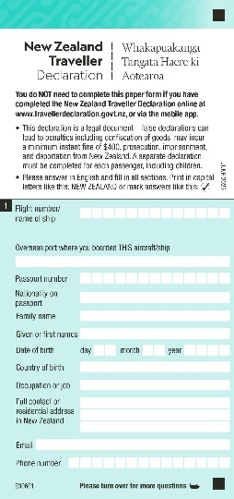

If you find the online declaration form hard then you can fill in a paper form when you get to New Zealand.

# What you need to fill in your

# New Zealand Traveller Declaration



To fill in your declaration you need to have:

your passport

your contact information like your mobile phone number

information about how you are getting to New Zealand which could be:

* by plane
* on a ship.

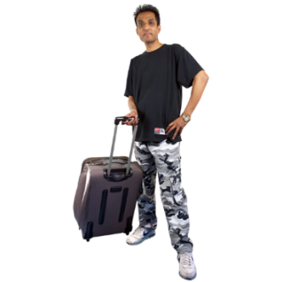information about where you have travelled in the last 30 days

information about what you are bringing into New Zealand.

There are some things that you cannot bring into Aotearoa   
New Zealand like:

foods like:

* animal products like cheeses



* plant products like fruits

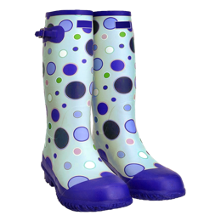

outdoor things with dirt on them.

These things may carry:

harmful pests like insects

diseases that could make people sick.

You may need to write in your form if you are bringing:

any kind of medicines



cigarettes

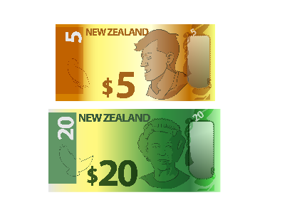alcohol like beer / wine

10 thousand New Zealand   
dollars / more than 10 thousand dollars in cash.



You can find more information about bringing things to New Zealand on the Customs NZ website at:

[**shorturl.at/bFOU0**](https://shorturl.at/bFOU0)

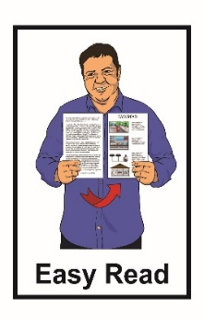

The information on this website is **not** in Easy Read.

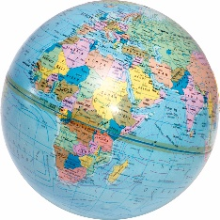To fill in your declaration you will also need:

your **immigration status**

your **visa** if you need one

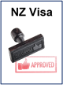

any visa information if you need a visa.

Your **immigration status** tells us:

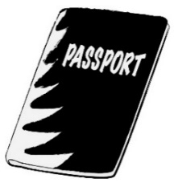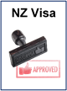

what kinds of things you can do in country like:

* the job you have / can do
* how long you can stay in a country

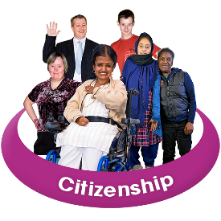if you are a **citizen** of:

* Aotearoa New Zealand
* Australia.

A **visa** is an official document that says you can come to / stay in a country.



A visa can be:

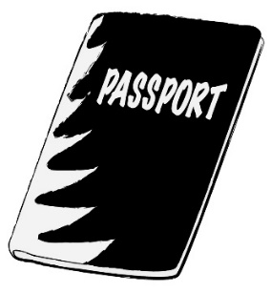a stamp in your passport

an electronic record if you have an e-passport.

A **citizen** is someone who can get a passport for the country they live in.

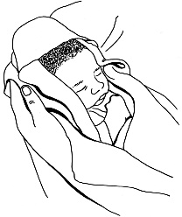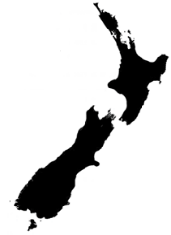

Many New Zealand citizens are born in New Zealand.

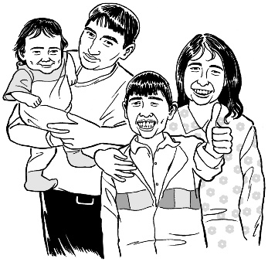

Some people who come to live in New Zealand from overseas also become New Zealand citizens.

# Information about visas



Some people do not need a visa to visit New Zealand like:

a New Zealand citizen

someone travelling with a   
New Zealand passport

someone from a **visa waiver country**.



A **visa waiver country** means a country whose citizens do not need a visa to visit Aotearoa New Zealand for a short time.

****A list of visa waiver countries is available on this website:

[**shorturl.at/fjsty**](https://shorturl.at/fjsty)

# A New Zealand Electronic Travel Authority



Some people also need to get a   
**New Zealand Electronic Travel Authority** to visit New Zealand**.**

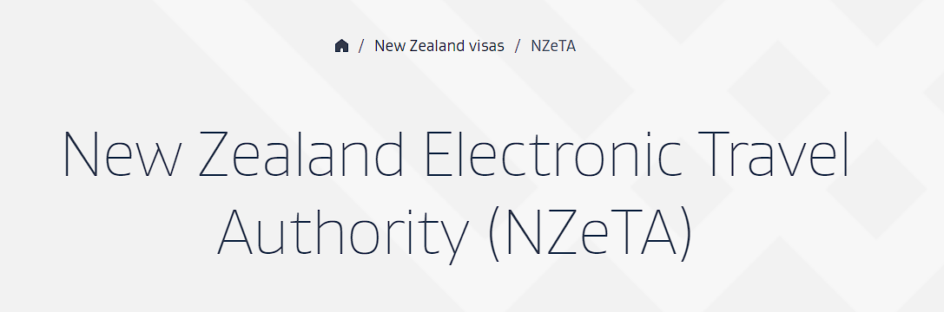

A **New Zealand Electronic Travel Authority** is also called an **NZeTA**.

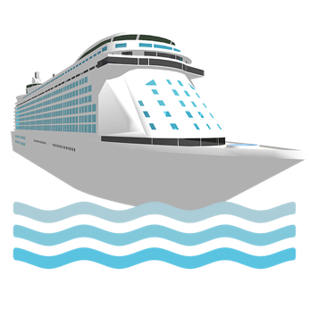People who need an NZeTA include:

people travelling on a ship

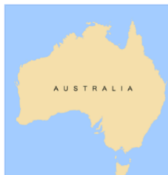people from a visa waiver country except people travelling on an Australian passport

**permanent residents** of Australia.

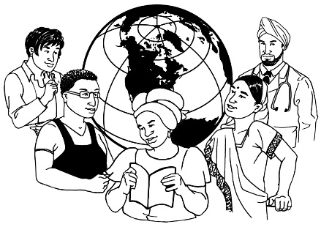An Australian **permanent resident** is someone who:

was not born in Australia

has been told by the Australian Government they can live in Australia all the time.

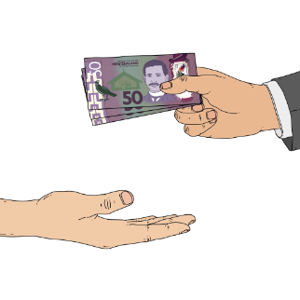To get an NZeTA you may need to prove that you:

have enough money to spend during your visit to Aotearoa   
New Zealand

have booked a way to leave New Zealand by:

* plane
* ship.

****More information about the NZeTA on the Immigration NZ website at:

[**shorturl.at/eCI17**](https://shorturl.at/eCI17)

The information on this website is **not** in Easy Read.



It is important to remember that:

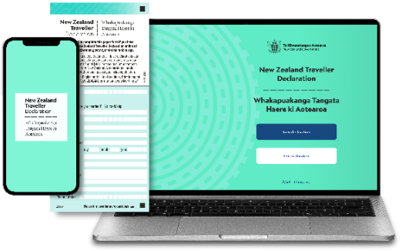everyone needs to do a declaration form before visiting New Zealand even if you have:

* a New Zealand visa



* an NZeTA

not everyone needs an NZeTA.

# When you can submit your

# New Zealand Traveller Declaration



You should fill in your declaration before you visit New Zealand.

If you are travelling on a plane the earliest you can submit your declaration is **24 hours / 1 day** before starting your trip to New Zealand.

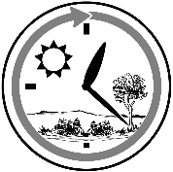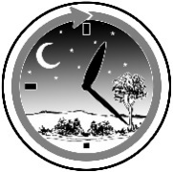

If you are travelling by sea the earliest you can submit your declaration is **24 hours** **/ 1 day** before you leave the last **international port** before you travel to New Zealand.



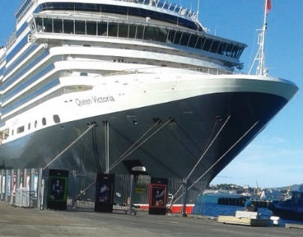An **international port** is a place where a ship stops in different countries.

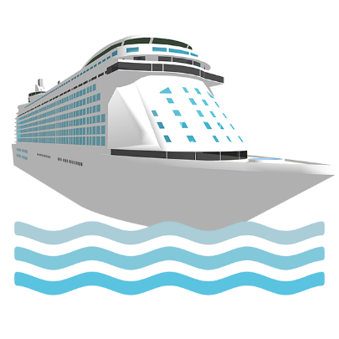You need to submit your declaration by the time you arrive at the first port in New Zealand if you are arriving by sea.

Your declaration is automatically checked when you arrive if you are travelling on a cruise ship.

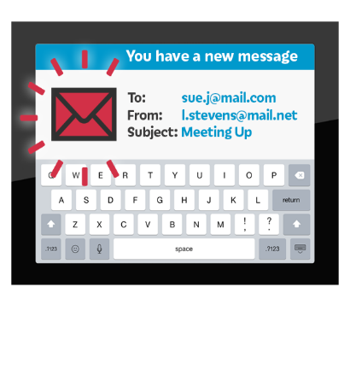

After you send us your declaration you will get an email about what you need to know when you enter

New Zealand.

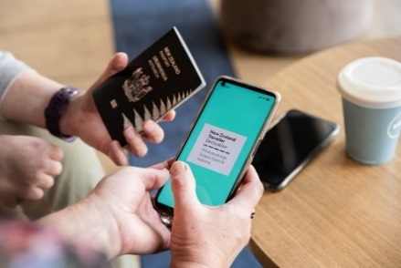

Your digital declaration is linked to your passport.

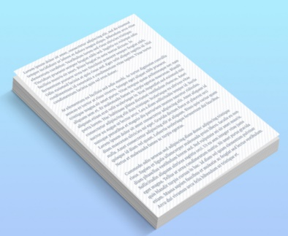You do not need to:

add any documents to your declaration

print your declaration out.

# Making changes to your

# New Zealand Traveller Declaration



You will be emailed a **reference number** when you start your declaration.

­Your **reference number** can be used to:

check your declaration

complete your declaration

make changes to your declaration.



You need to keep your reference number somewhere safe because you might need it when you arrive in New Zealand.

If you make any changes to your declaration online you will need to submit it again.

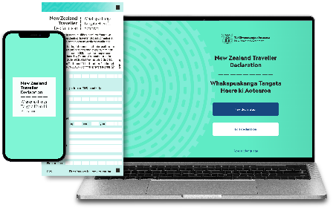

You can make changes to your declaration until you reach **passport control** in New Zealand.

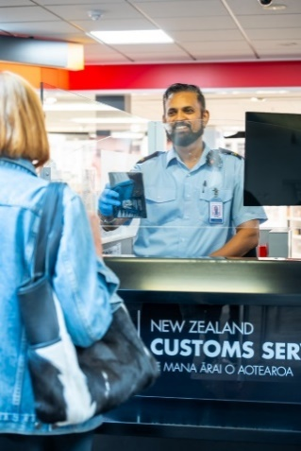

**Passport control** is where your passport gets checked before you are allowed into New Zealand.

If you have forgotten to say you have brought something with you in your declaration you will need to talk to a **border officer**.

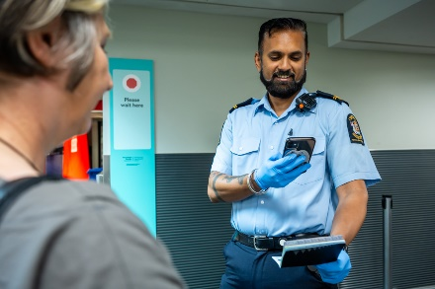

A **border officer** is a person who checks that you can enter New Zealand.

# When you arrive in New Zealand

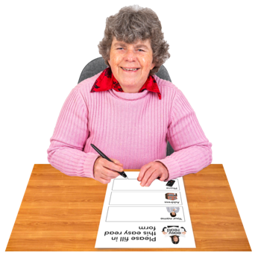

You can fill in a paper declaration when you get to New Zealand if you have not done a declaration online.

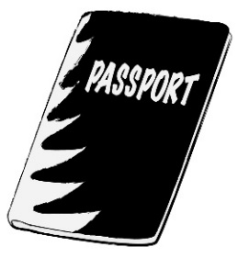  
Your declaration will be checked:

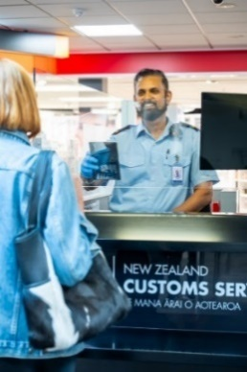when you scan your passport at the eGate  
  
or

by a border officer on arrival into New Zealand  
  
or

automatically if you arrive on a ship.

Your bags may be:

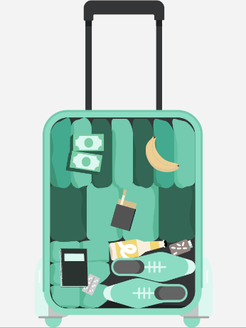 **x-rayed**

checked.

An **x-ray** is a machine that can see what is inside your bags.

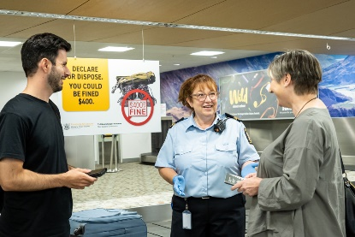

If you have forgotten to say you have brought something with you in your declaration you may:

* have to pay money like a fine

be taken to court in the future.

# Checklist for travelling to New Zealand

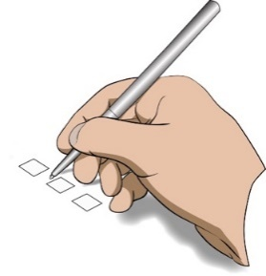

These are the things to do before travelling to New Zealand:

check that your passport is up to date

apply for a visa if you need one

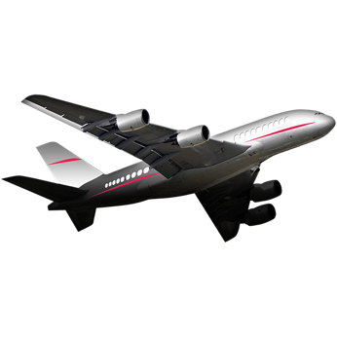apply for an NZeTA if you need one

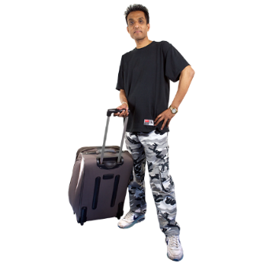book how you are getting to New Zealand

check what you can bring into New Zealand

submit your declaration.



# How to contact us

  
  
If you have any questions about the New Zealand Traveller Declaration you can phone us.

Our contact centre is open:



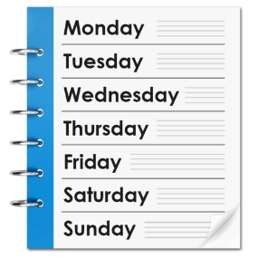24 hours a day

7 days a week.

In New Zealand you can phone:

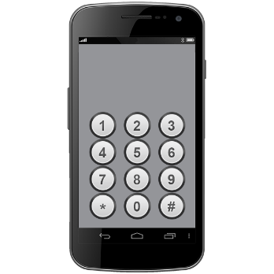

**0800 359 269**



This number is free to call if you are in New Zealand.

If you are calling from Australia you can phone:

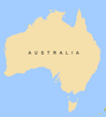

**1800 359 269**



This number is free to call if you are in Australia.

If you are calling from any other country you can phone:

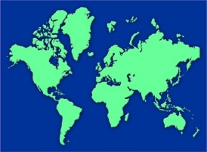

**+64 4 931 5799**



You may be charged money for these calls.

You can also send us message online through the New Zealand Traveller Declaration website at:

[**shorturl.at/acfH6**](https://shorturl.at/acfH6)

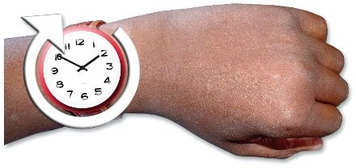We will try to answer your message within 12 hours.

**Te Kāwanatanga o Aotearoa – 
New Zealand Government logo.
**This information has been written by

Te Kāwanatanga o Aotearoa –

New Zealand Government.

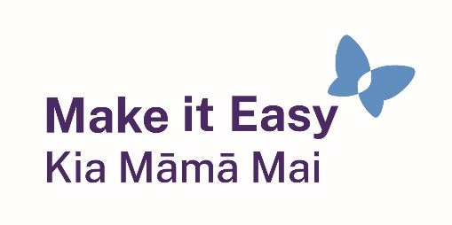It has been translated into Easy Read by the Make it Easy Kia Māmā Mai service of People First New Zealand Ngā Tāngata Tuatahi.

The ideas in this document are not the ideas of People First New Zealand Ngā Tāngata Tuatahi.

Make it Easy uses images from:

* Changepeople.org
* Photosymbols logoPhotosymbols.com
* SGC Image Works



* Huriana Kopeke-Te Aho
* T. Wood.

  
All images used in this Easy Read document are subject to copyright rules and cannot be used without permission.